1 OVERVIEW

1.1 Business Goals
Providing online store services to customers who can buy branded items supplied by vendors.

1.2 Business Process Overview

Customer goes through Registration process first, then in Customer profiling process all his details will be processed and saved in Backend System.
After that user can go to Shopping process, in which he can Search for products and add them to Shopping cart.
Order Management takes care of orders made by customer.
Next, Payment Settlement process will be done with the help of banks which are responsible for Visa / Mastercard that used by customer.
As soon as payment is made, our system will do Fulfillment Service, which asks Vendors to send the ordered product and send notification to the customer as well.

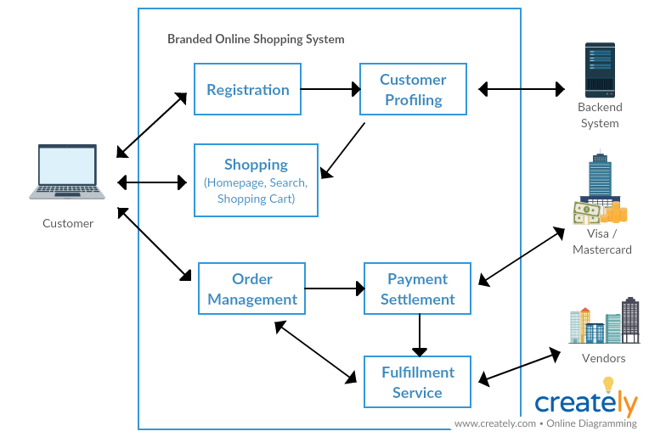

You can edit the diagram by going to the link:
https://creately.com/diagram/jupvko8h1/k31OqGp909w2K4JKhPDGPZhv4M%3D

1.3 Objectives of System

Registration, Customer Profiling, Shopping, Order Management, Payment Settlement, Fulfillment Service.
2 BUSINESS PROCESS

Process maps and business functions are documented for each business process identified in the overview.

2.1 Process maps

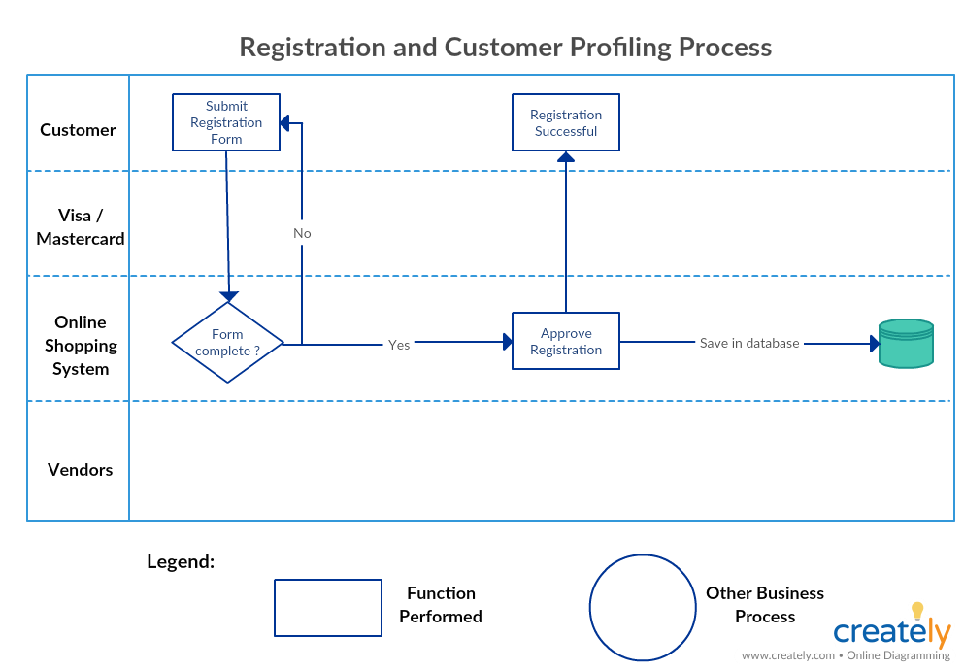

You can edit the diagram by going to the link:
https://creately.com/diagram/juq4ehhl1/XsBj1mZnOM98bPh2ErfwP8IsGrA%3D

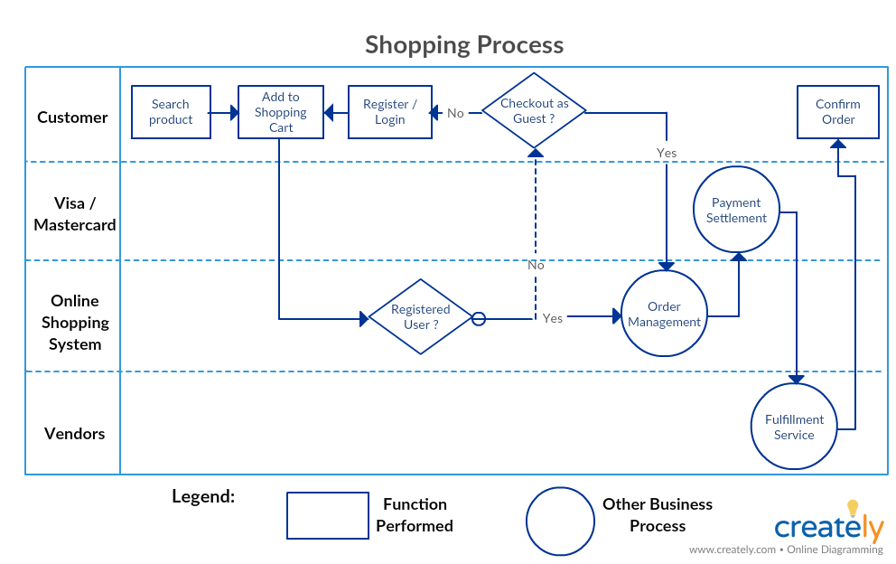

You can edit the diagram by going to the link:
https://creately.com/diagram/junftyfq1/Ql0Rc9Xevthi729psP0Y6g4MI%3D

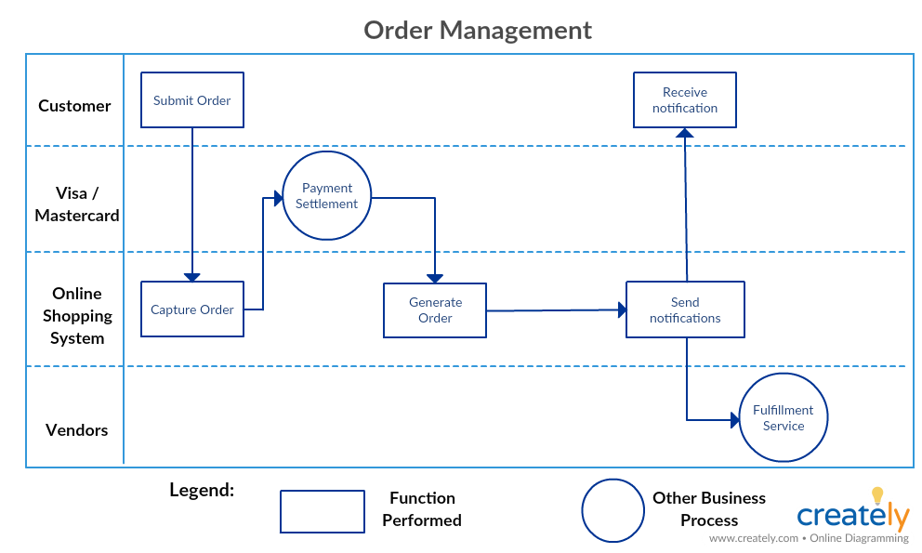

You can edit the diagram by going to the link:
https://creately.com/diagram/jun1k1bn1/HzXCfdhiQ2Ej07IZKSzMOcsK2dg%3D
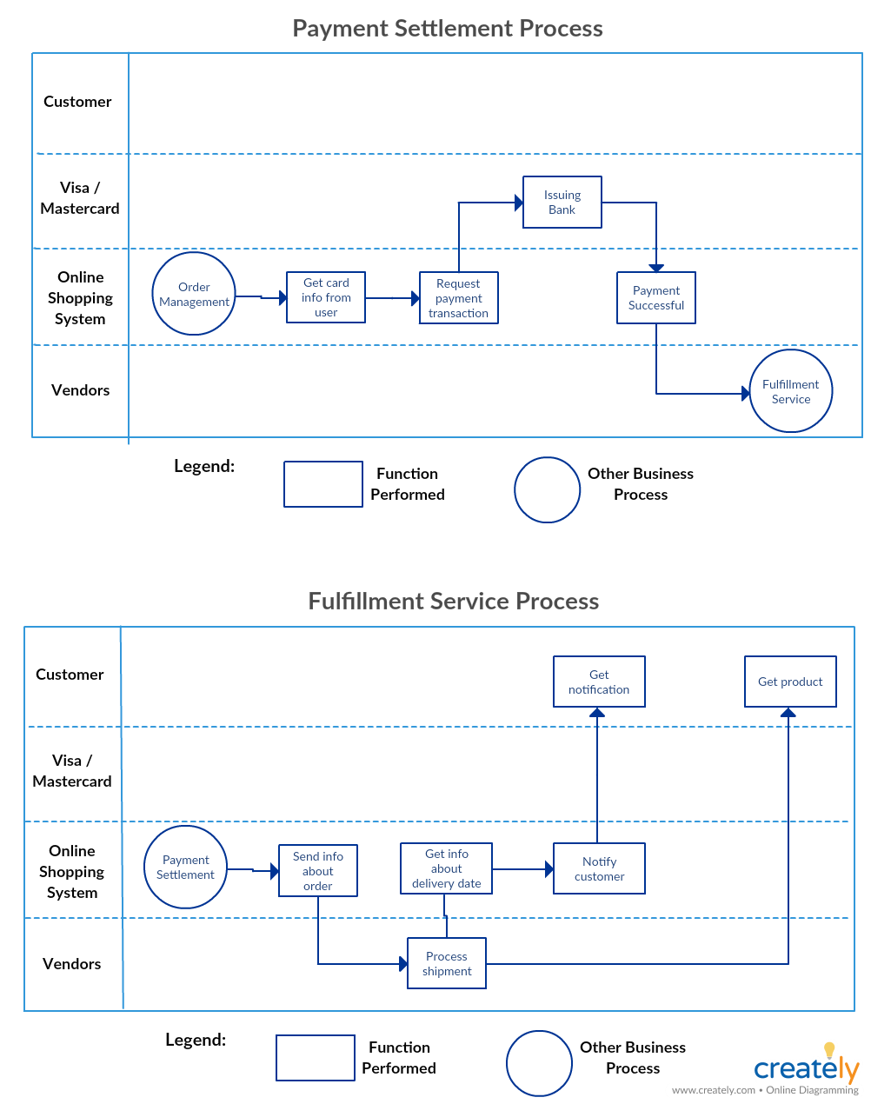

You can edit the diagram by going to the link:
https://creately.com/diagram/jun2jadr1/ZZo99pbder6UFUd3ZuaFRwmrS1s%3D

3 BUSINESS FUNCTIONS

3.1 Functional Overview

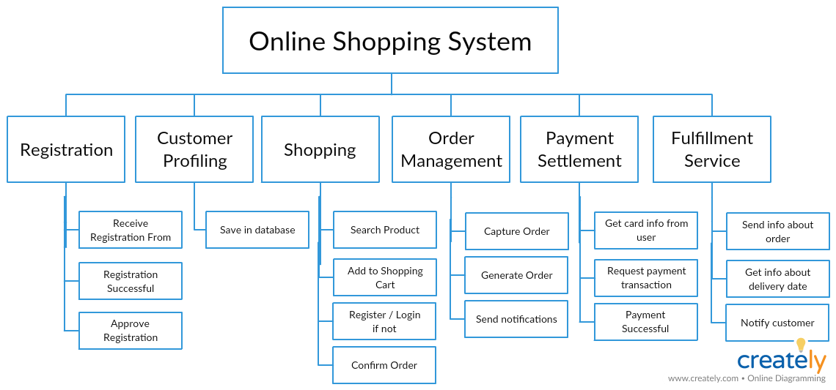

You can edit the diagram by going to the link:
https://creately.com/diagram/jurh5d4e1/akRONmQtHZO9xMzlYihQoGQQyg%3D

3.2 Functional Requirements

Process Name: Registration
Function Description: the main function of this process is gathering End-User data and send it to the Back-end to process and saved to the database.
Roles: End-User (Customer – Vendor)
Input: End-User data
Output: Java object ready to map into persistent object.

Process Name: Login
Function Description: the main function of this process is checking the user credentials and privileges.
Roles: End-User (Customer – Vendor)
Input: End-User stored data
Output: authorized user profile.

Process Name: Shopping
Function Description:
- the main function of this process is capturing searching criteria, process, retrieving, then displaying the appropriate results.
- Creating a shopping cart and order products
Sub-process: Searching
Function Description:
- the main function of this process is capturing searching criteria, process, retrieving, then displaying the appropriate results.
Roles: End-User (Customer)
Input: searching criteria
Output: retrieved data from database.

Sub-process: create a shopping Cart
Function Description:
- the main function of this process is creating a shopping cart.
Roles: End-User (Customer)
Input: get shopping cart
Output: created shopping cart.

Process Name: Payment Settlement
Function Description: the main function of this process is capture user financial info, process, and send a payment transaction
Roles: End-User (Customer)
Input: End-User financial data
Output: transaction done/fail confirmation.

a) Event Table

Sequence No. | Role’s Action | System Response
1.1 | User gets Registration form | The system displays the Registration form
1.2 | User inserts correct data | The system captures the data, process, and fill the appropriate role’s object.  Then send it to be saved into database  The system displays a successful registration message
1.3 | User inserts incorrect data | The system throws the corresponding exception and sends an error message back to the user
2.1 | User inserts correct credentials | The system retrieves user data from database, verify, then approve.  The system sends the user’s profile
2.2 | User inserts incorrect credentials | The system retrieves user data from database, verify, and displays an error message to the user
2.3 | User try to login before registration | The system cannot retrieve user data from database, then displays an error message to the user
3.1 | User inserts valid criteria variables | The system captures the inserted variables, process, retrieve data from database, and send results back to the user
3.1 | User inserts invalid criteria variables | The system captures the inserted variables, process, and send an error message back to the user
3.3 | Authorized/login User asks for creating a shopping cart | The system creates a shopping cart and sends back
3.4 | Un-login user asks for creating a shopping cart | The system displays a message asks user to login or register
3.5 | User makes an order | The system adds products to the order
3.6 | User confirm the order | The system gets out an order
4.1 | User submit/confirm order | The system displays payment form to the user
4.2 | User insert financial data | The system capture data from user, verify, perform transaction
4.3 | User insert incorrect financial data | The system displays an error message

- 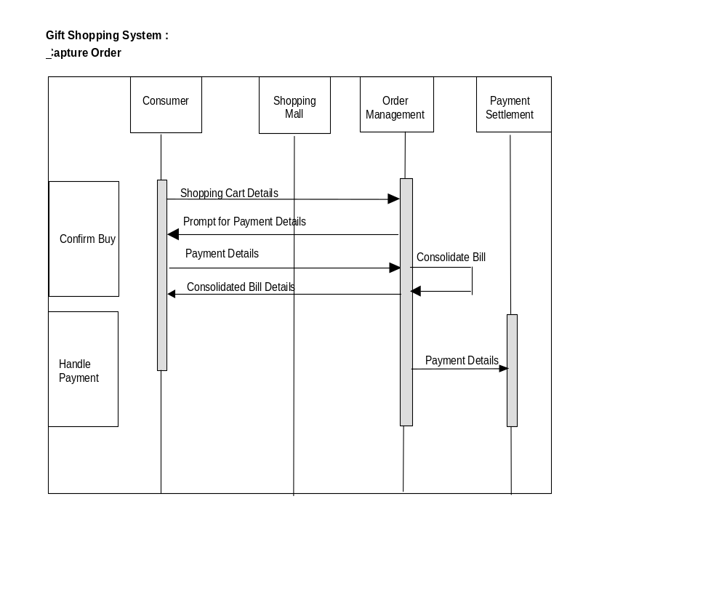Sequence Diagram

4 OTHER REQUIREMENTS

The non-functional requirements are documented as follows :

- SYSTEM PERFORMANCE

- System response and turnaround time

Response time is the amount of time from the moment that a user sends a request until the time the application indicates that the request has completed.
Turnaround time is the total time taken between the submission of a program for execution and the return of the complete output to the customer.
- All internal system response time should be less than 3 seconds.
- All Rest API call must response within 5 seconds, otherwise set the time out.

- System availability

The service will be up on every day except on Sunday (12:00 AM – 4:00AM by weekly) for system maintenance.

- SECURITY REQUIREMENTS

- The system will categorize users into three groups ( admin, customer/guest, vendor). Only authenticated and authorized users are allowed to perform requested functions.

- The system will use the Spring security and use the BCryptPasswordEncoder. BcryptPasswordEncoder is a strong hashing algorithm with randomly generated salt, which will be used to hash a password and perform a login authentication.

3) The application shall not violate its security requirements as a result of the upgrading or replacement of a data, hardware, or software component.

- EXTERNAL INTERFACES

Software interfaces – The application communicates with payment gateway in order to validate the credit card and perform the purchase transaction. The system will decide based on the response of the payment system to indicate the further processing of the user purchase.

Communication interfaces – The communication between the different parts of the
system is important since they depend on each other. The application will handle with MySQL connection and internal communication.

- ARCHIVAL REQUIREMENTS

The system will backup product Catalog periodically and store locally.

- Retention period for each generated product catalog will be one year.

- The catalog and reports will be transferred off-line to the external hard disk or other cloud storage after one year ( retention period).

- CONTINGENCY REQUIREMENTS

For critical business functions ,

- Tolerable downtime – bi weekly on Sunday(12:00 AM -> 4:00 AM)

- If there is an incident of DB occurred, all records must be restored from the backup within two hours.

- If system crash or the application is down due to some attack, the Disaster Recovery (DR) must be in place and system should be able to start within an hour.

- CONVERSION REQUIREMENTS

N/A

- STATUTORY REQUIREMENTS

All products which is available to sell on the application should not violate any laws and regulations. (Eg: Guns and explosive materials, pornography products and uncensored books should be restricted and blocked to sell on the application)

5 SYSTEM/OPERATING ENVIRONMENT

a) Communications Overview
  - Secure Internet connection (Https)
  - The port on which Tomcat listens must be open for the application

b) Hardware Requirements/Configuration
- Database Server (MySQL Server 8.0.15)
- Application and front- end Server for hosting
- Require space (5GB) for backed up product catalog

c) System Software
- Operating System
- JDK8

- ASSUMPTIONS AND LIMITATIONS

Scope – The scope will not change and the team will follow the architecture diagram, WBS and iteration plan.

Methodology – Project will follow agile methodology through the execution
Project will follow team governance guidelines and requirements

Technology – The team will implement the solutions using JAVA , Spring and hibernate.
The solution will use Junit test environment.

Architecture & Design - The application will utilize REST API architecture
Team will follow the MVC design pattern throughout the project.

Constraints – The payment gateway should be available before the application start up.
MysqlDB must be installed correctly.

7 USER INTERFACE DESIGN CONCEPT

The UI will be designed using bootstrap and details will be as below. The design will be minimal, simple and elegant.

- Background - White
- Screen layout – Full page
- User interactions - Smooth
- Text font / style - Poppins
- Icons - FontAwesome
- Buttons – Red Rounded corner
- Frames – Left sidebar and full page
- Header / Footer / Terms and Conditions – Simple

8 SCENARIO FLOW / USER INTERFACE DEMO

Scenario 1 – Admin Role:

- Admin must be able to login/register the system and be able to manage different functionalities.
- The admin shall be view the list of vendors under manage vendor page.
- The system must allow admin to approve/ delete the selected vendor.
- The admin can add , update or delete the different product Category.
- The admin can also add/ update or delete the other administrators.

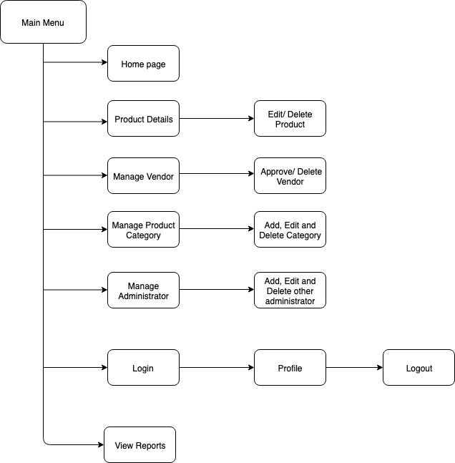

Fig 1 : Admin Flow (End to End)

Scenario 2 – Customer Role :

- The customer must be able to login/register to mStore branded online portal.
- The system shall validate the user and the product catalog page will be displayed to authenticated and authorized user.
- If customer is the guest user, he can perform one time purchase by following below steps.
- The user shall be able to select desired products from product catalog page and add to the shopping cart.
- The system shall allow user to be able to add, remove and edit the quantity in the shopping cart.
- Once user is ready to proceed the payment, system must display the UI details for customer to key in the credit/debit card details and shipping address.
- Once user confirmed, system shall connect to payment gateway.
- Once identification is successful, transaction is completed and user will be able to see the order details and receipt.
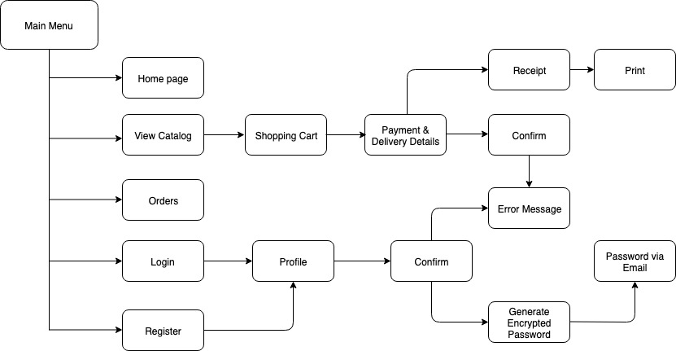

Fig 2 : Customer Flow (End to End)

Scenario 3 - Vendor Role:

- Vendor must be able to login/register to the system and able to access vendor related functions.
- The system shall allow the supplier/vendor to add/edit/delete the product.
- Vendor shall be able to view the list of products and be able to generate the reports based on the selection.
- The report should be able to generate ad-hoc and user will be able to save or view the generated report.

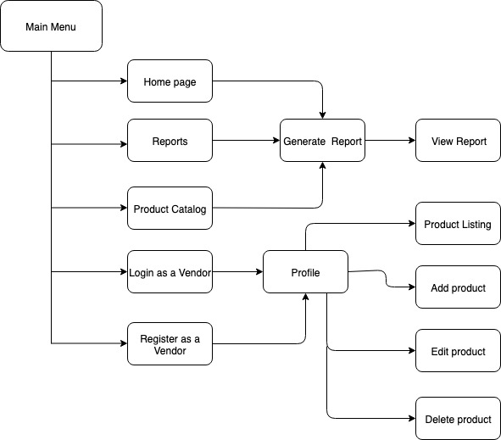

Fig 3 : Vendor Flow (End to End)

